2024

Vũ Phạm Thế

12/21/2024

Guide Document

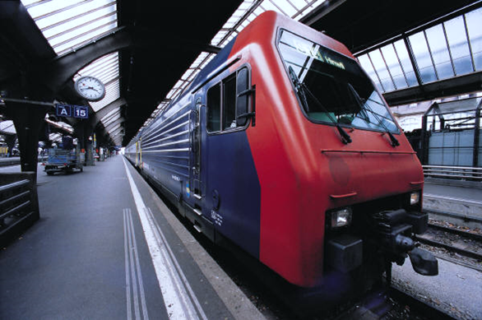

Record of change

| No | Effective Date | Version | Change Description | Reason | Updated By |
| --- | --- | --- | --- | --- | --- |
| 1 | Dec-21-2024 | 1.0 | Initial document | Create | VuPT |
|  |  |  |  |  |  |
|  |  |  |  |  |  |
|  |  |  |  |  |  |
|  |  |  |  |  |  |
|  |  |  |  |  |  |
|  |  |  |  |  |  |
|  |  |  |  |  |  |

Contents

1. DEPLOYMENT 3

2. First RUN SeTUP 4

2.1. Web client: 4

1. DEPLOYMENT
   * Step 1: Clone/extract source code.
   * Step 2: On Visual Studio Code. Right click to ASW.BE folder then choice Open in Terminal

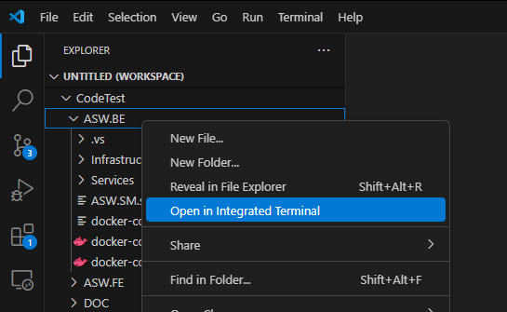

* + Step 3: Run command at Terminal: docker compose up --build (make sure on your laptop/PC has docker desktop)
  + Step 4: Have a coffee and wait it done ☺

1. First RUN SeTUP
   1. Web client:
   * Step 1: go to <http://localhost:4200>

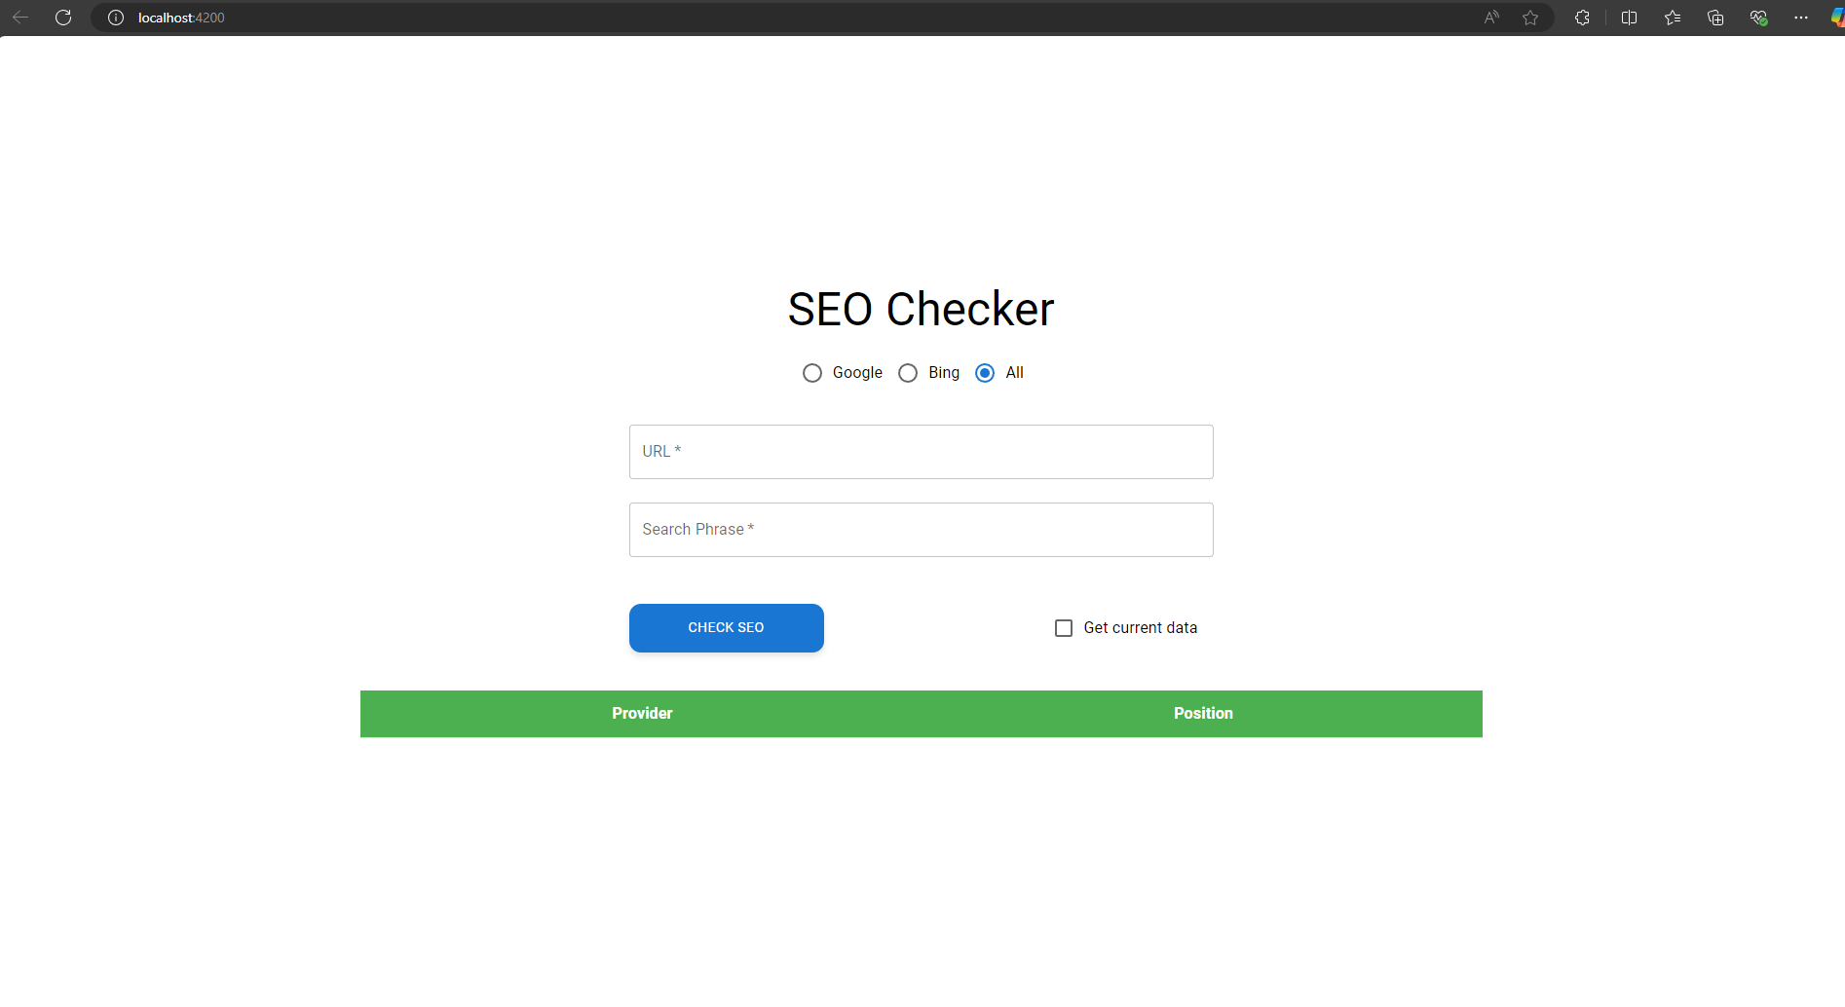

* + Step 2: enter the Url and Search Phrase then click to CHECK SEO Button to show the result

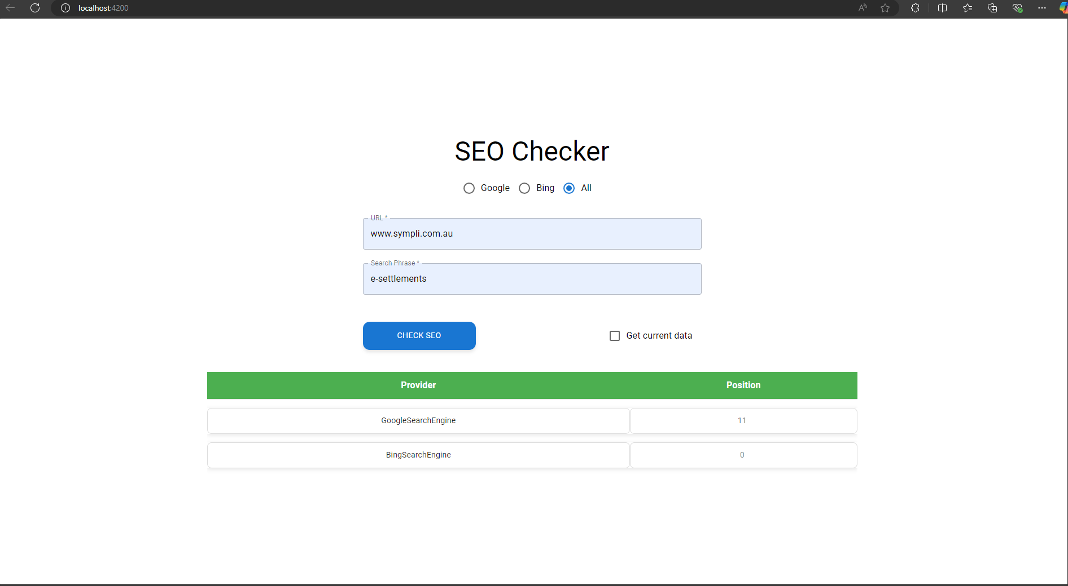

* + Step 3: Click to CheckBox Get current Data if you want to bypass cache check feature.

